MATHEMATICAL AND SOFTWARE SUPPORT DEVELOPING OF THE POSITIONING SYSTEM IN LINEAR NETWORKS

A. Semenov^{1*}, M. Dubinin², E. Kazakov^{3,4}, D. Kolesov²
*sasfeat@mail.ru
¹ Wuhan University, China, Wuhan
² LLC «NextGIS», Russian Federation, Moscow
³ Saint Petersburg State University, Russian Federation, Saint Petersburg
⁴ Nansen International Environmental and Remote Sensing Center, Russian Federation, Saint Petersburg

KEYWORDS: positioning, indoor-navigation, spatial data analysis

ANNOTATION: Review of open source mobile application for indoor-positioning on the example of subway.

The presence of areas without satellite signals leads to the need to create and implement alternative ways of positioning [1]. The problem of positioning in indoor linear systems is a special case for three-dimensional space with unlimited transfer. As a prototype of such systems can take a transport network, including underground, e.g. underground. We consider the problem of the development of the methodology for determining the user's location based on indirect data sources. For the research method chosen for positioning on the base stations of the cellular network (identifiers and signal strength). Depending on the location can be either only information about the signal is available (at the stations), or be taken into account the dynamics of changes in his powers (on the stretch). Illustrated scheme of work for data collection network-and mobile sensors.
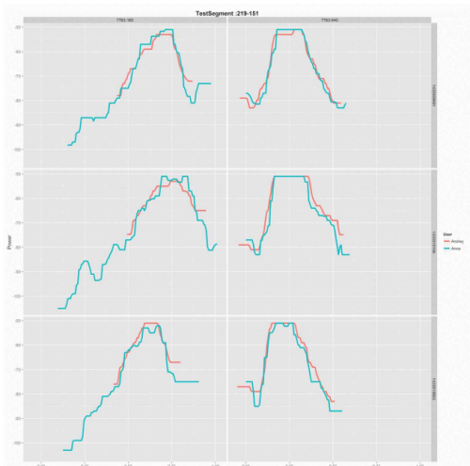
Figure 1. The behavior of cell signals on the test drive. The shift signals for the devices
Describes the process of preparation, analysis, processing and final presentation of spatial databases as well as key points of development, evaluating the accuracy and testing of the algorithm of the prediction location. In the final part, deals with the creation stage of application, summed up the interim results of its use, as well as the issues of further improvement of the applied technologies.

References
- Pahlavan K., Li X., Makela J. P. Indoor geolocation science and technology // IEEE Communications Magazine. — 2002. — Feb. — Т. 40, № 2. — p. 112—118.

